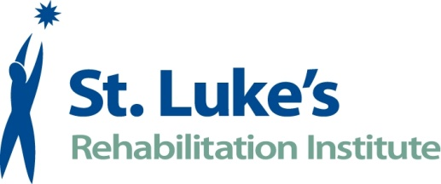  For Immediate Release  June 13, 2016 | Contact:  Nicole Stewart  24-Hour Newsroom: (509)232-8300  newsroom@inhs.org

Rehabilitation Associates Transitions to St. Luke’s
Drs. Mackenzie and Varga Join St. Luke’s Physiatry Practice
SPOKANE, Wash.–Long-time St. Luke’s partners and physiatrists, Keith Mackenzie, MD, PS and Mark Varga, MD of Rehabilitation Associates, recently joined St. Luke’s Physiatry Practice, bringing their practice and patients under St. Luke’s Rehabilitation Institute for continued care in outpatient and inpatient settings.
Dr. Keith Mackenzie has been practicing rehabilitation for 37 years in Spokane. He received his medical education at the University of Washington and completed a family medicine residency before completing his physical medicine and rehabilitation (PM&R) residency at the University of Washington.

Dr. Mark Varga began his medical training at George Washington University in Washington D.C. and went on to gain vast Naval Aviation medical experience in primary care, emergency medicine and sports medicine. Dr. Varga completed residency in PM&R at Frazier Rehab Institute through the University of Louisville. He has been an admitting physician at St. Luke’s for 17 years.

“We are excited to officially become part of the St. Luke’s family of physiatrists and interdisciplinary teams” said Dr. Varga. “Rehabilitation Associates’ patients have been seen at St. Luke’s for years and will continue to receive the most comprehensive rehabilitation in both inpatient and outpatient settings .”

St. Luke’s Physiatry Practice has grown to 11 physiatrists and three physician assistants, expanding patient access and bringing additional knowledge and services in physical medicine and rehabilitation.

“Drs. Mackenzie and Varga’s medical knowledge of the Spokane community and surrounding area is unparalleled,” said Dr. Gregory Carter, St. Luke’s medical director. “Combining their top-notch clinical education and passion to deliver the best in physiatry care, the St. Luke’s Physiatry Practice is caring for more patients with a multitude of illnesses and injuries.”

With the physicians joining St. Luke’s, patients of Rehabilitation Associates were transitioned to St. Luke’s on May 31, 2016.

For more information, please call (509) 473-6706 or visit www.st-lukes.org/Admissions-Referrals/.
About St. Luke’s Rehabilitation Institute
The region’s largest, free-standing Level I Trauma Rehabilitation hospital, St. Luke’s provides comprehensive medical rehabilitation services for people of all ages who have experienced a stroke, spinal cord injury, brain injury, amputation or other injury or illness requiring rehabilitative care. St. Luke’s is accredited by The Joint Commission and Commission on Accreditation of Rehabilitation Facilities International. Thousands of patients choose St. Luke’s for inpatient rehabilitation services at the main campus and outpatient therapy services at nine locations throughout Spokane. For more information on St. Luke’s visit:
Web: www.st-lukes.org Facebook: www.facebook.com/stlukesrehab
YouTube: www.youtube.com/thebuzzinhs Twitter: twitter.com/stlukesrehab

###

